Co- vs. counter-diffusional substrate delivery in a hollow-fiber membrane biofilm reactor
H. Nielsen¹*, T. Lippert¹, P. Nannapuraju¹, A. Freiburger^{1,2}, Y. Lin², G. Wells¹
¹ Northwestern University, Department of Civil and Environmental Engineering, 2145 Sheridan Road, Evanston, IL 60208
² Argonne National Laboratory, Applied Materials Division, 9700 S. Cass Avenue, Lemont, IL 60439
*Corresponding author: heather.nielsen@northwestern.edu
Abstract: This study compares the performance and microbial community structure of a lab-scale, hollow-fiber membrane biofilm reactor (MBfR) for ex-situ biomethanation to produce pipeline-ready renewable natural gas (RNG) in two feeding configurations. The co-diffusional feeding regime delivers gaseous substrates H₂ and CO₂ via the membrane lumen, while counter-diffusion delivers H₂ via the membranes and CO₂ as dissolved HCO₃⁻ salt in the bulk liquid. Both configurations yielded high-quality biomethane (>93% CH₄). However, the ideal stoichiometric feed ratio in co-diffusion (3.95:1), and corresponding CO₂ conversion efficiency (89.8%) were higher than those in the counter-diffusional system (3.42:1, 78.8%). Biofilm in co-diffusional was unevenly distributed and formed long streamers, while counter-diffusional had a uniform thickness. Both feeding regimes enriched for hydrogenotrophic methanogens, dominated by M. Methanobacterium. However, counter-diffusion had lower relative abundance of other methanogenic species. Results suggest that co-diffusion results in more efficient substrate utilization and greater species diversity for operational stability.
Keywords: Renewable natural gas; ex-situ biomethanation; hollow-fiber membrane biofilm reactor
Introduction
Biogas upgrading to RNG can be achieved by supplying H₂ gas to a bioreactor to convert the excess CO₂ in biogas to CH₄ via methanogenesis. Mass transfer of substrate gas into the bulk liquid is a major factor in improving biomethanation performance (Feickert Fenske et al., 2023). Improved H₂ mass transfer via hollow-fiber membrane delivery has been utilized in many resource recovery and remediation applications, including a handful of studies on ex-situ biomethanation (Díaz et al., 2015; Miehle et al., 2021; Pratofiorito et al., 2021). Additionally, advantages of substrate counter-diffusion using membranes as an active, rather than inert, biofilm attachment surface are well documented (Nerenberg, 2016). For the first time, this study compares the performance of a hollow fiber membrane biofilm reactor (MBfR) for ex-situ biomethanation under counter-diffusion (i.e. H₂ is delivered in membrane lumen, CO₂ is delivered as HCO₃⁻ from the bulk liquid) to its relative performance in a co-diffusional feeding regime (i.e. H₂ and CO₂ delivered through the membrane lumen). The two feeding regimes were compared in terms of 1) biomethane quality 2) maximum CH₄ production capacity and 3) substrate utilization efficiencies, with an additional focus on emergent differences in microbial community structure and biofilm characteristics.
Material and Methods
The MBfR was fabricated using gas-tight components. Temperature was maintained at 37±1°C. Substrate gases were delivered via mass flow controllers (MFCs) to a 350-count membrane bundle of 0.4mm diameter, microporous HDPE hollow fiber membranes (SFC Umwelttechnik GmbH, Salzburg, Austria) suspended in a cylindrical chamber. In the co-diffusional setup, pH was maintained at 7.0±0.1. In the counter-diffusional feeding regime, pH was maintained at 7.5±0.1, and CO₂ was delivered as a 1:1 KHCO₃:NaHCO₃ dissolved salt solution. Figure 1 shows a simplified process flow diagram. Composite biomethane samples were analyzed for CH₄, CO₂, and H₂ daily using a gas chromatography thermal conductivity detector (GC-TCD) and the gas production was measured using a BlueVCount gas counter (BlueVCount, BlueSens gas sensor GmbH, Herten, Germany). Both experiments were inoculated using biomass sourced from a municipal anaerobic digester. Biomass samples were collected for 16S rRNA sequencing. Sequences were mapped using MIDAS v5.3 (Dueholm et al., 2024).
Results and Discussion
While experimental work is still in progress to determine the maximum production capacity of the counter-diffusional setup, both feeding regimes demonstrated capacity to produce high quality biomethane (Figure 1). The co-diffusional experiment yielded a maximum CH₄ production rate of 6.98 ± 0.13 m³CH₄/m³d at a 7-day average gas quality of 93.3 ± 1.0% CH₄, 0.9 ± 0.7% CO₂, 5.8 ± 0.5% H₂. The current production capacity of the co-diffusional setup is 3.88 m³CH₄/m³d with an average gas quality of 93.6 ± 0.5% CH₄, 1.3 ± 0.2% CO₂, 5.0 ± 0.6% H₂. Notable differences emerge, however, when comparing stoichiometric feed ratios and conversion efficiencies (i.e. the fraction of fed substrate that is converted to CH₄). In co-diffusion, a feed ratio of 3.95:1 regularly yielded gas quality above 95% and as high as 98%. In counter-diffusion, however, a feed ratio of 3.42:1 is required to reach the same quality targets. This yields H₂ conversion efficiencies >90% to CH₄ in both experiments, but lower conversion efficiencies for CO₂ in the counter-diffusional setup (78.8% vs. 89.8% under co-diffusion).
Biofilm morphology differed considerably between the two setups. Co-diffusion yielded an unevenly distributed pale grey biofilm with long streamers, while counter-diffusion yielded an evenly distributed dark grey biofilm with uniform thickness (Figure 2). (Figure 3). In co-diffusion, Shannon diversity decreased from 5.6 in the inoculum to a minimum of 1.9 in the final sample (co 300), corresponding to a rise in relative abundance of methanogens generally (82%), shared between M. Methanobacterium (68%) and an unidentified species of the genus Methanobacteriaceae (13%). In counter-diffusion, diversity reduced to 1.9 in the most recent sample (ctr 104). In this case, M. Methanobacterium represents almost the entirety of methanogenic species (77%) with a very small fraction of other methanogens (<3%).
Conclusions
While the counter-diffusional experiment is still in progress, results thus far suggest that co-diffusion supports greater species diversity and CO₂ conversion efficiency. Further experimentation will determine whether the counter-diffusional feeding regime is able to achieve a higher specific methane production rate.
Acknowledgements
Funding for this research was provided by the United States Department of Energy.
References
Díaz, I., Pérez, C., Alfaro, N., Fdz-Polanco, F., 2015. A feasibility study on the bioconversion of CO2 and H2 to biomethane by gas sparging through polymeric membranes. Bioresour. Technol. 185, 246–253. https://doi.org/10.1016/j.biortech.2015.02.114
Dueholm, M.K.D., Andersen, K.S., Korntved, A.-K.C., Rudkjøbing, V., Alves, M., Bajón-Fernández, Y., Batstone, D., Butler, C., Cruz, M.C., Davidsson, Å., Erijman, L., Holliger, C., Koch, K., Kreuzinger, N., Lee, C., Lyberatos, G., Mutnuri, S., O’Flaherty, V., Oleskowicz-Popiel, P., Pokorna, D., Rajal, V., Recktenwald, M., Rodríguez, J., Saikaly, P.E., Tooker, N., Vierheilig, J., De Vrieze, J., Wurzbacher, C., Nielsen, P.H., 2024. MiDAS 5: Global diversity of bacteria and archaea in anaerobic digesters. Nat. Commun. 15, 5361. https://doi.org/10.1038/s41467-024-49641-y
Feickert Fenske, C., Kirzeder, F., Strübing, D., Koch, K., 2023. Biogas upgrading in a pilot-scale trickle bed reactor – Long-term biological methanation under real application conditions. Bioresour. Technol. 376, 128868. https://doi.org/10.1016/j.biortech.2023.128868
IEA, 2025. Outlook for biogas and biomethane: A global geospatial assessment (Special Report), World Energy Outlook. International Energy Agency (IEA), France. https://doi.org/10.1787/040c8cd2-en
Jabornig, S., Podmirseg, S.M., 2015. A novel fixed fibre biofilm membrane process for on‐site greywater reclamation requiring no fouling control. Biotechnol. Bioeng. 112, 484–493. https://doi.org/10.1002/bit.25449
Miehle, M., Hackbarth, M., Gescher, J., Horn, H., Hille-Reichel, A., 2021. Biological biogas upgrading in a membrane biofilm reactor with and without organic carbon source. Bioresour. Technol. 335, 125287. https://doi.org/10.1016/j.biortech.2021.125287
Nerenberg, R., 2016. The membrane-biofilm reactor (MBfR) as a counter-diffusional biofilm process. Curr. Opin. Biotechnol. 38, 131–136. https://doi.org/10.1016/j.copbio.2016.01.015
Pratofiorito, G., Hackbarth, M., Mandel, C., Madlanga, S., West, S., Horn, H., Hille-Reichel, A., 2021. A membrane biofilm reactor for hydrogenotrophic methanation. Bioresour. Technol. 321, 124444. https://doi.org/10.1016/j.biortech.2020.124444

Figures and Tables
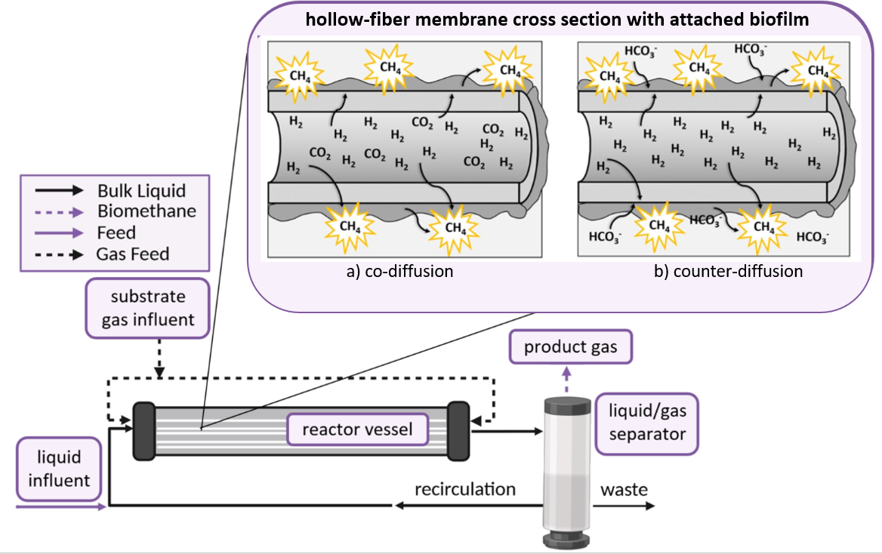
Figure 1. Process flow diagram of hollow-fiber membrane biofilm reactor (MBfR) showing the two substrate feeding regimes compared in this study. Panel a) represents co-diffusion of gaseous substrates H₂ and CO₂ from the lumen of the membrane into the attached biofilm and bulk liquid. Panel b) represent counter-diffusion of gaseous H₂ from the membrane lumen and aqueous HCO₃⁻ from the bulk liquid into the biofilm. Both feeding regimes utilize the membranes as an active biofilm attachment surface.

Table 1. Key performance parameters for the co- and counter-diffusional experimental work showing the maximum observed CH₄ production rate at which product gas quality exceeded 90% CH₄. The associated 7-day average values for substrate feed ration, product gas composition (% CH₄, H₂, and CO₂), and substrate conversion efficiencies. It should be noted that the counter-diffusional experimental work is still in progress and the maximum production capacity may ultimately be higher than shown.
Parameter | Unit | Co-diffusion | Counter-diffusion (in progress)
Specific CH₄ Production Rate | m³CH₄/m³d | 6.98 ± 0.13 | 3.88 ± 0.11
Substrate Feed Ratio | H₂:CO₂ | 3.95:1 | 3.42:1
Gas Quality
CH₄ | % | 93.3 ± 1.0 | 93.6 ± 0.5
H₂ | % | 5.8 ± 0.5 | 5.0 ± 0.6
CO₂ | % | 0.9 ± 0.7 | 1.3 ± 0.2
Conversion Efficiency
H₂ | % | 90.9 ± 0.0 | 92.1 ± 0.0
CO₂/HCO₃⁻ | % | 89.8 ± 0.0 | 78.8 ± 0.0

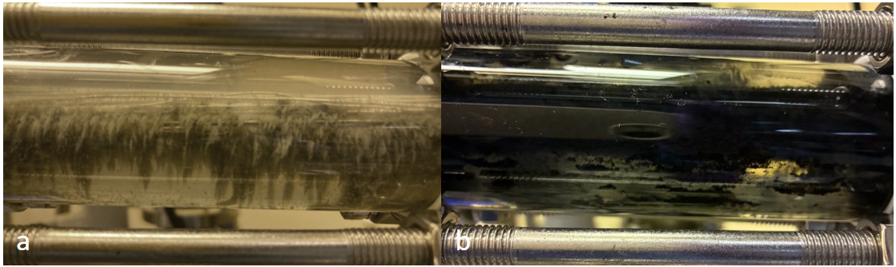
Figure 2. Photographs of biofilm attachment to the membrane bundle showing differences in morphology between the two experimental runs. Panel a represents the co-diffusional run, which had a pale grey, unevenly attached biofilm with long streamers, while Panel b represents the counter-diffusional run which formed a dark, evenly distributed biofilm.

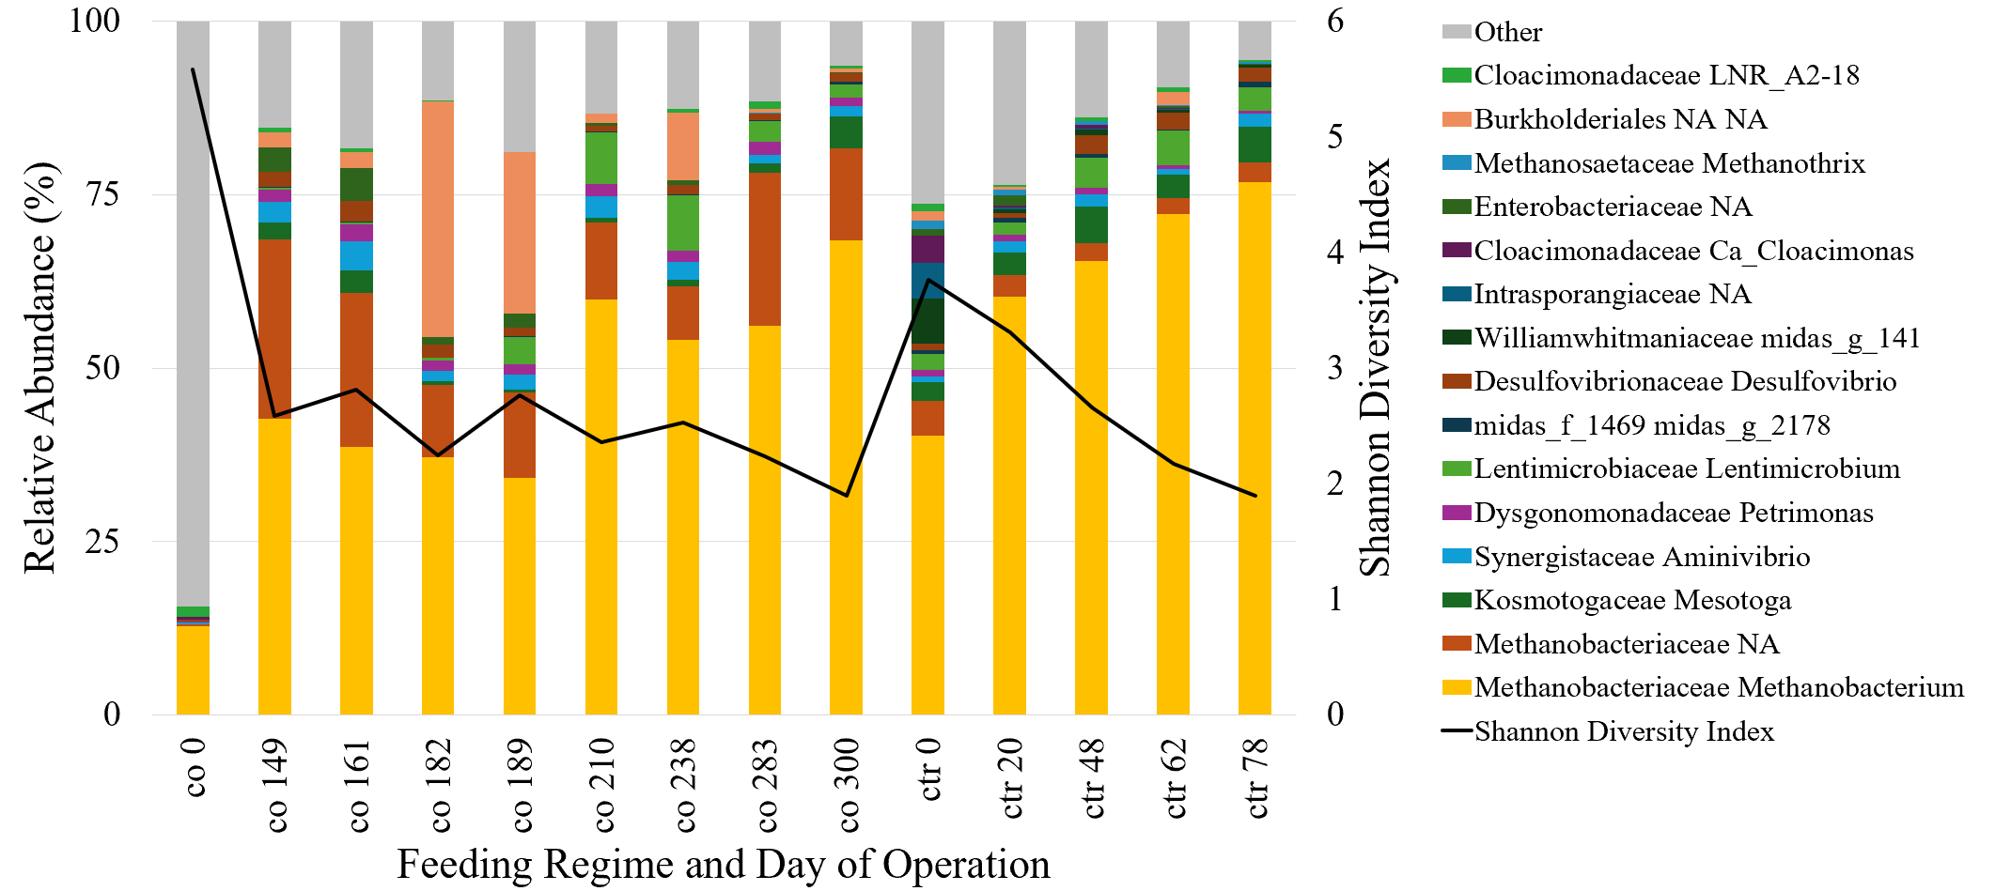
Figure 3. Relative abundance of genus and species level taxonomies assigned to unique ASVs mapped to the MIDAS 5.3 database and Shannon Diversity Indices for the co- and counter-diffusional experimental runs. The top 10 most abundant ASVs for each sampling date were condensed into a composite list of genus and species plotted above, with all other ASVs categorized as “Other.” Samples are represented on the x-axis according to feeding regime day of operation (i.e. “co 161” corresponds to Day 161 of the co-diffusional experimental run). The first 150 days for the co-diffusional experiment are excluded due to variations in the nutrient solutions during that startup period.

